**Assignment 1**

**Task 1:**

Write a Python program to print the following string in a specific format (see the output).

Twinkle, twinkle, little star, How I wonder what you are! Up above the world so high, Like a diamond in the sky. Twinkle, twinkle, little star, How I wonder what you are.

**Source Code:**

print("Twinkle, twinkle, little star,")

print("\tHow I wonder what you are! ")

print("\t\tUp above the world so high,")

print("\t\tLike a diamond in the sky.")

print("Twinkle, twinkle, little star,")

print("\tHow I wonder what you are")

**Output:**

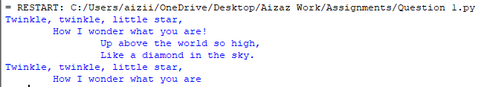

**Task 2:**

Write a Python program to get the Python version you are using.

**Source Code:**

import sys

print("Python version")

print (sys.version)

**Output:**



**Task 3:**

Write a Python program to display the current date and time.

**Source Code:**

import datetime

now = datetime.datetime.now()

print ("Current date and time : ")

print (now.strftime("%Y-%m-%d %H:%M:%S"))

**Output:**



**Task 4:**

Write a Python program which accepts the radius of a circle from the user and compute the area.

**Source Code:**from math import pi

r = float(input ("Input the radius of the circle : "))

print ("The area of the circle with radius " + str(r) + " is: " + str(pi * r**2))

**Output:**



**Task 5:**

Write a Python program which accepts the user's first and last name and print them in reverse order with a space between them.

**Source Code:**

fname = input("Input your First Name : ")

lname = input("Input your Last Name : ")

print ("Hello " + lname + " " + fname)

**Output:**

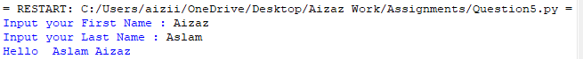

**Task 6:**

Write a python program which takes two inputs from user and print them addition.

**Source Code:**

num1 = input('Enter first number: ')

num2 = input('Enter second number: ')

# Add two numbers

sum = int(num1) + int(num2)

# Display the sum

print('The sum is',sum)

**Output:**

